CSA1708-ARTIFICIAL INTELLIGENCE
LAB EXPERIMENTS
Program 17 : Prolog Program to Sum the Integers from 1 to N
Aim
To write a recursive Prolog program that calculates the sum of integers from 1 to N.
Algorithm
1. Define the base case: the sum of integers up to 0 is 0.
2. For a positive N, reduce it by 1 and recursively find the sum up to N - 1.
3. Add N to the partial sum returned by the recursive call.
4. Query the predicate with a number and display the resulting sum.
Program
sum_to_n(0, 0).
sum_to_n(N, Sum) :-
N > 0,
Previous is N - 1,
sum_to_n(Previous, PartialSum),
Sum is N + PartialSum.
Sample Input
?- sum_to_n(5, Sum).
Program Execution
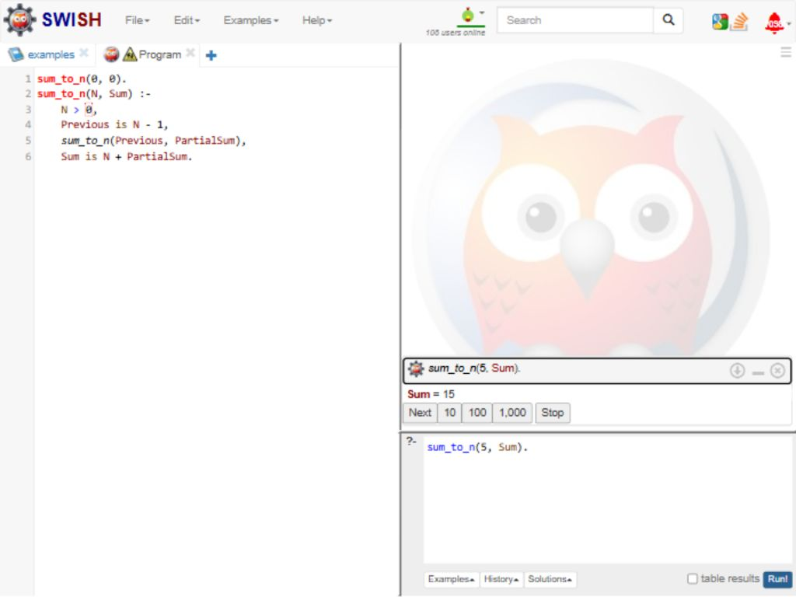
RESULT
Thus, the Prolog program recursively calculated the sum from 1 to 5 as 15.

